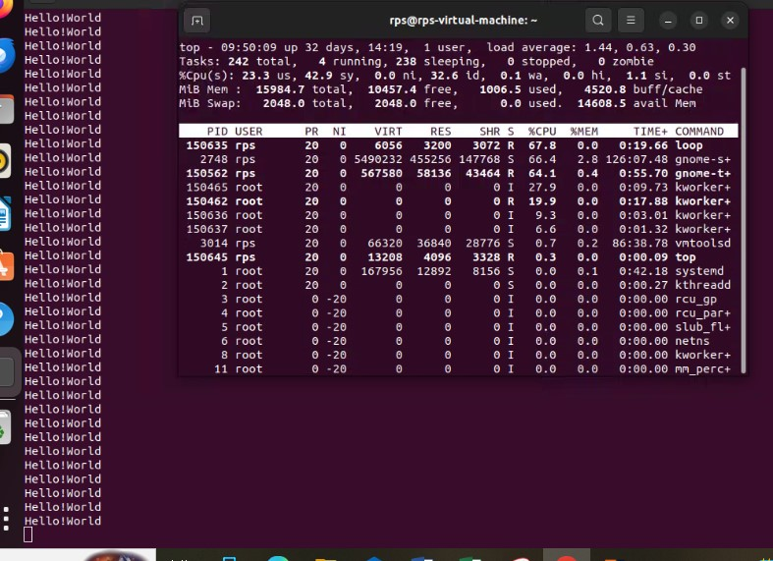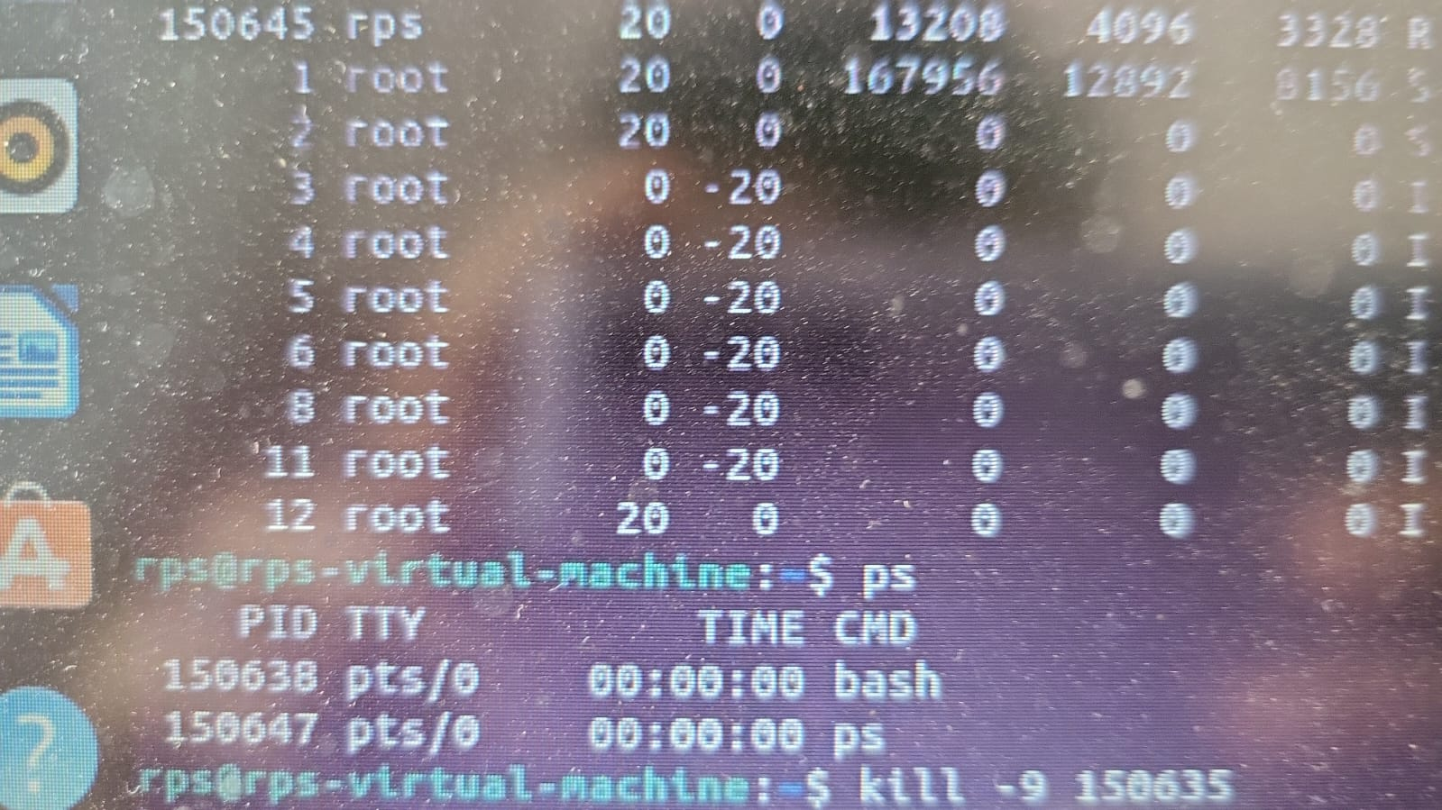

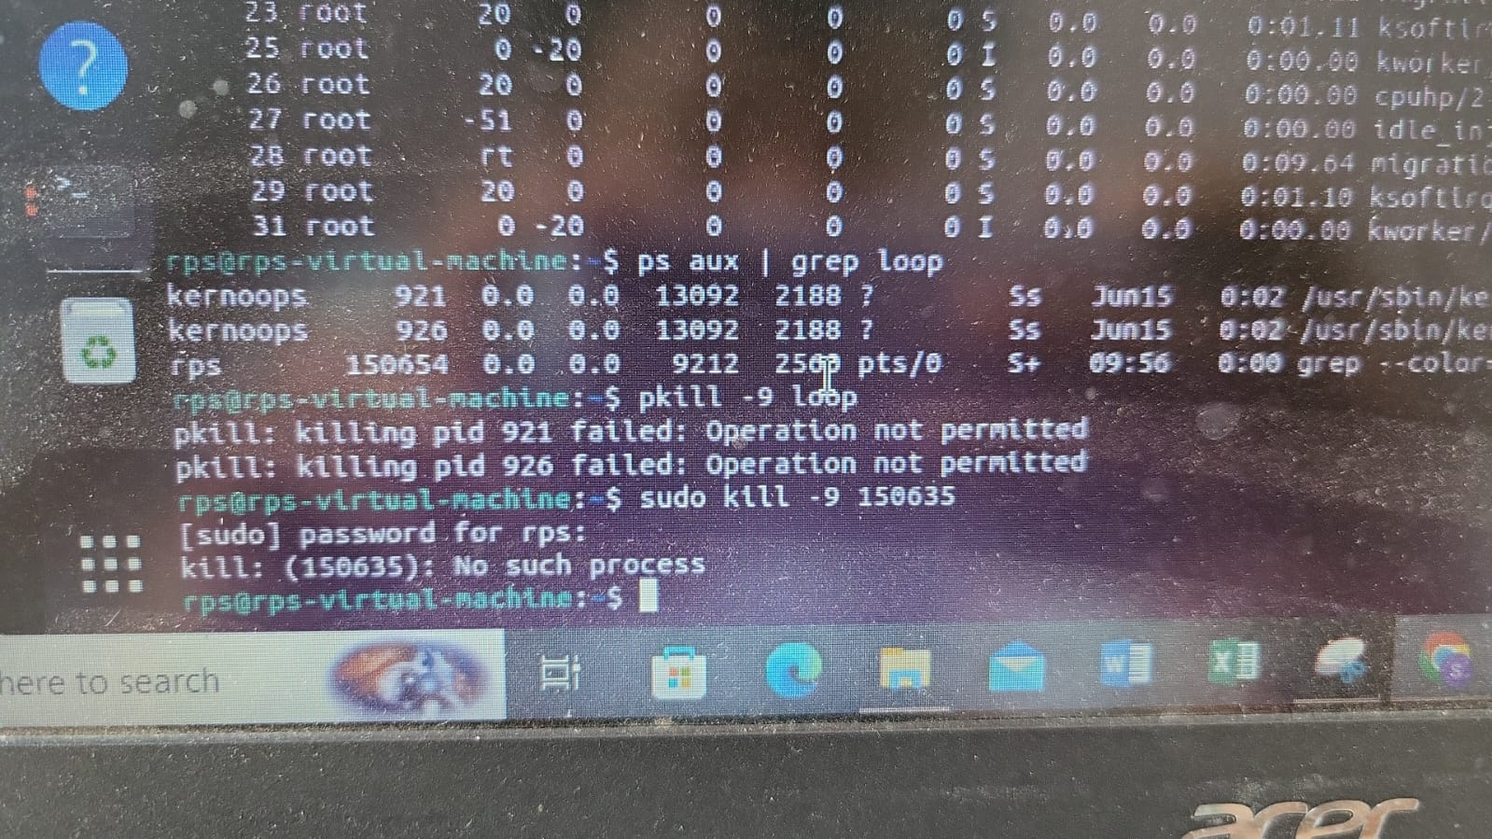

No such process exit

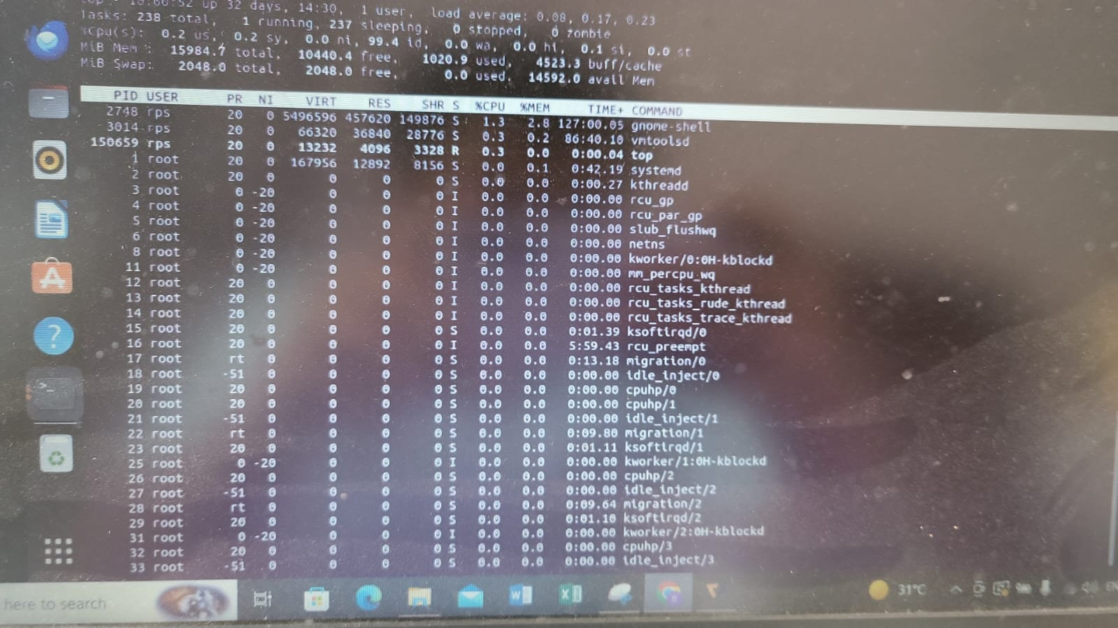

Hello World (cat command)

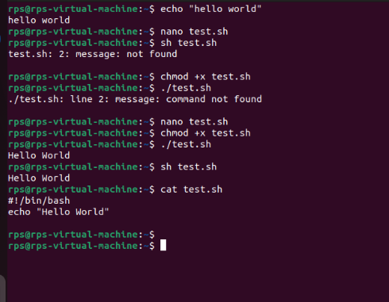

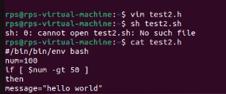

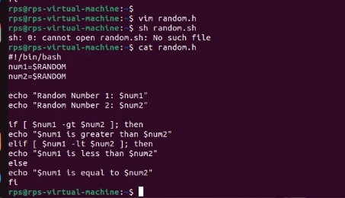

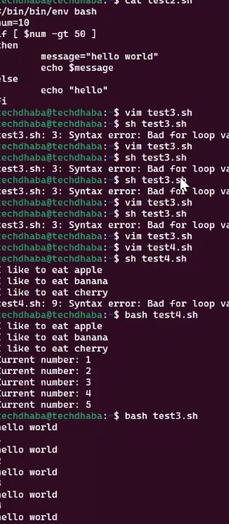

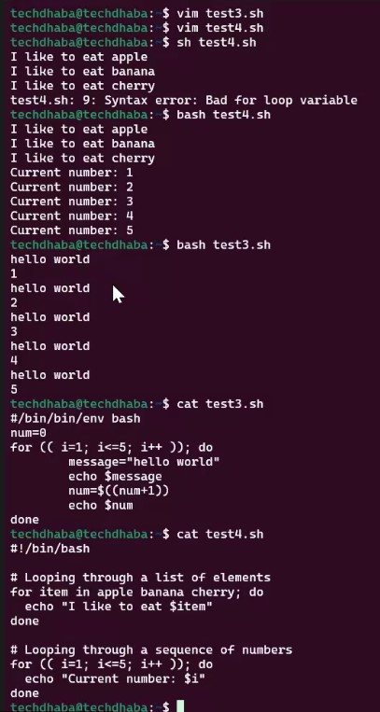

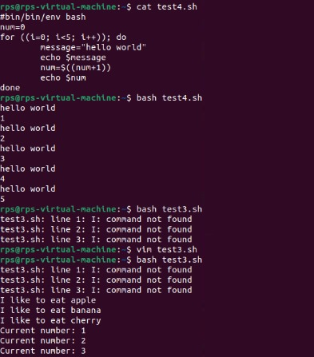

Exercise 1: Write a shell script called num_loop.sh that loops through every number 1 through 20 and prints each number to standard output. The script should also conditionally print I'm big! for every number larger than 10. give me the answer

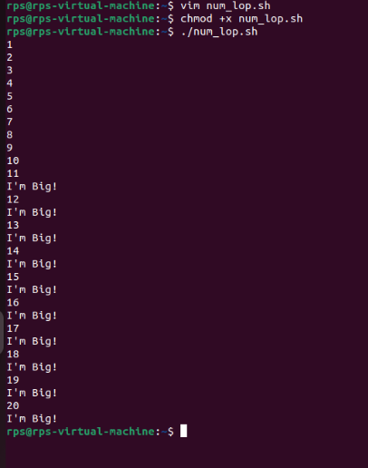

Bash Scripiting : Functions

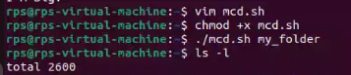

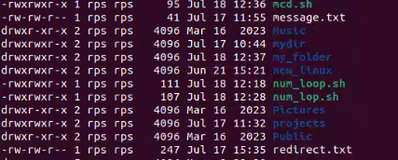

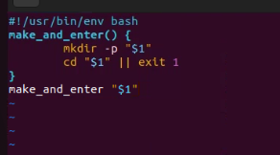

Exercise 2: Write a shell script called my_folder.sh that takes in two arguments: your name (e.g. ayelet) and your name with the.txt ending (e.g. ayelet.txt). The script should call a function that creates a folder by the name of the first argument (e.g. ayelet) and then create a file inside by the name of the second argument (e.g. ayelet.txt). For my name, my function would create a folder named ayelet and a file named ayelet.txt inside of ayelet. give me propr code usinng vim.

